Global Warming is not Manmade
Varangian Vikings made wine in Greenland at the peak (Vinland), and then came down into Russia right after the peak. Other Vikings came down to Europe and England also at that time. Now, life on the Varangian Peninsula and in Greenland is almost impossible, too cold.
Medieval Warm Period Climate Science Stats:
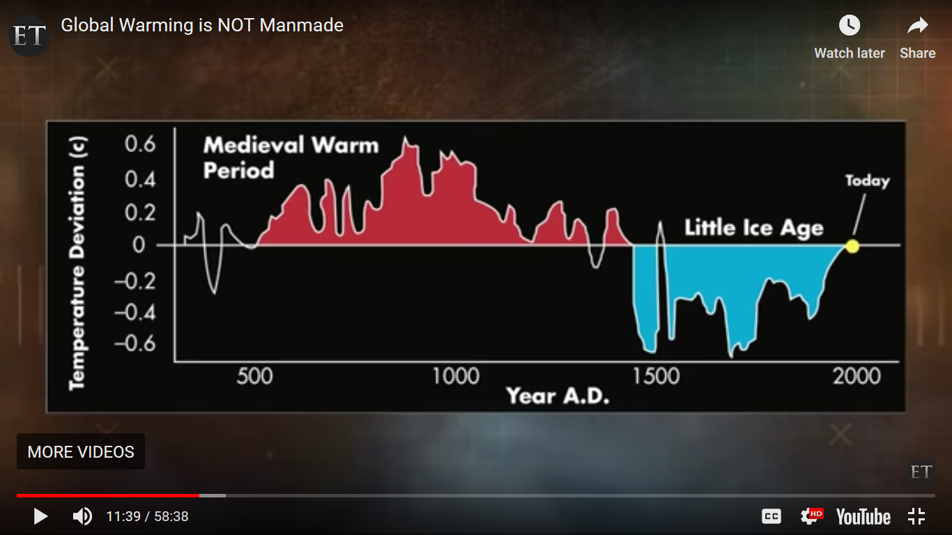
Start from 1860 and this same scientific climate change data looks like this:
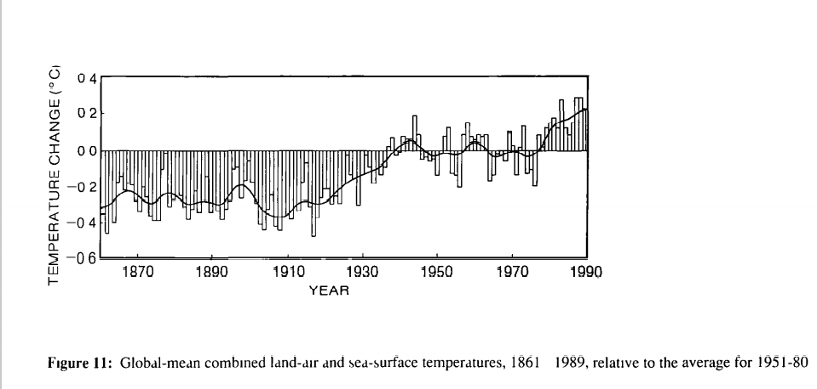
Plus: see how CO² follows temperature, not temperature caused by CO² in VP Gore’s scientific graphs.

