Global Warming/Climate Change is not Manmade
Climate science stats say CO2 follows warming and Cooling:
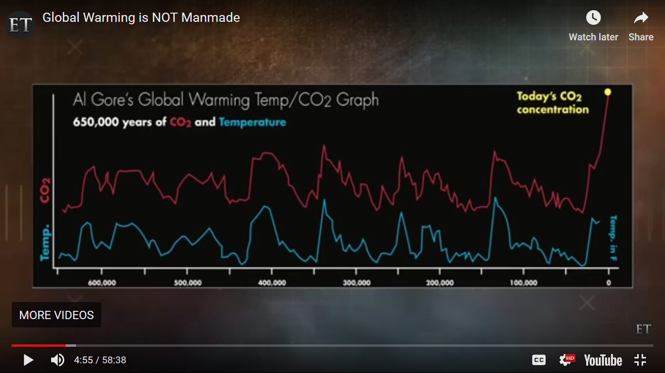

That’s Al Gore’s Graph. I assume it is climate science. Mine would start at 6,000 and end at 0. Either way, it is easy to see that the red line follows the blue line. Industrialization increased CO2. Lately, CO2 has greatly increased and the temperature has gone down.
So, neither is Global Cooling/Climate Change manmade.
Climate Change is required for One World Government. Along with ending the strong nation states, US and Russia. In my work with the saints of the church, for the last 150 years with the exception of the Pentecostal saints, the western saints have all been progressive towards this one world government. I always include their Wikipedia descriptions and in those we can drill down to everything they have ever said, written, or joined. Doing this, I have found that their plan to remove the US is Climate Change and Gun Control. The plan for Russia is to misrepresent who they are. They are represented as still wanting to take over the world, still communist, when in fact they are just trying to protect Orthodox Christians. The same thing happened before WWI at the end of the Ottoman Empire. That fall threatened Orthodox Christians everywhere, and the Russians were their only protection. At that time the progressives portrayed that protection as aggression as they do now. They have been Orthodox protection since 1453. Checkout the Saints stories to see what I am talking about.

